

**Tech Saksham**

Case Study Report

Data Analytics with Power BI

**“360-degree Business Analysis of Online Delivery Apps using Power BI”**

**“A.P.C.Mahalaxmi College for Women”**

|  |  |
| --- | --- |
| **NM ID** | **NAME** |
| 932C157E1A16F7FACBC4C955095FD54F | JENITHA.V |

**Trainer Name:** J.Arockia Jeyanthi

**Master Name:** Uma Maheswari

**ABSTRACT**

Online delivery apps have revolutionized the way we access goods and services. By leveraging mobile technology, these apps connect users with a vast network of vendors, enabling the seamless delivery of everything from food and groceries to medications and household essentials. This abstract explores the key features and functionalities of online delivery apps, highlighting their impact on consumer behavior and the broader retail landscape.

**INDEX**

|  |  |  |
| --- | --- | --- |
| **Sr. No.** | **Table of Contents** | **Page No.** |
| 1 | Chapter 1: Introduction | 1 |
| 2 | Chapter 2: Services and Tools Required | 3 |
| 3 | Chapter 3: Project Architecture | 5 |
| 4 | Chapter 4: Modeling and Result | 7 |
| 5 | Conclusion | 10 |
| 6 | Future Scope | 11 |
| 7 | References | 12 |
| 8 | Links | 13 |

**CHAPTER 1**

**INTRODUCTION**

* 1. **Problem Statement**

When a user orders food to the wrong location,they must contact customer service which causes delay.

What can I do to prevent this from happening?

* 1. **Proposed Solution**

I placed a map preview to update the current location of delivery before ordering .The User can expand the map and easily navigate through the map to select an exact drop off location.

* 1. **Feature**
* **Food Ordering:**Allowing the users to order their food on -the-go from two different restaurants.
* **Table Booking:** Enables the users to book a table at the listed restaurant of their choice with just a few taps and the wait time at the restaurant is eliminated.
* **Explore Places:** Offering the discovery and guide to the user for exploring nearby restaurants with pictures, reviews and map locations.
* **Online payments:** online payments facilitate the flow of the money in the right direction, a step forward to corruption – free India.
  1. **Advantages**
* Opened 24/7
* Save time and money
* Reduce costs
* Hits the target market
* Online delivery mechanism
* Food can be ordered from multiple sources
* Paper wastage is reduced
* Route optimization is attained
  1. **Scope**

In order to drive this growth, consumers are increasingly using food delivery apps. These apps offer convenience and ease of use, allowing customers to order food from their favoriterestaurantswithout having to leave their homes. Additionally, with the ongoing COVID-19 pandemic, more people are opting for contactless delivery options, further boosting the growth of the food delivery app market.

**CHAPTER 2**

**SERVICES AND TOOLS REQUIRED**

* 1. **Services Used**
* **Data Integration Services:** Services for data integration are crucial for collecting and consolidating data from various sources such as transactional databases,customer feedback platforms,delivery tracking systems and market research databases.
* **Data Warehousing:**Storing and organizing data efficiently is essential for performing analytics effectively.Data Warehousing Services such as Azure synopse Analytics Redshift can be used to store large volumes of structured and unstructured data for analysis.
* **Cloud Storage:** Cloud storage solutions like Azure Blob Storage or Amazon S3 can be used to store raw data,intermediate data,and processed datasets securely,making it accessible for analysis by Power BI and other tools.
* **Machine Learning Services:**Integrating Machine Learning models into the analysis pipeline can provide predictive analytics capabilities for tasks such as demand forecasting,customer segmentation,and route optimization.Azure Machine Learning or Amazon sagemaker are examples of machine learning services that can be integrated with Power BI.

**2.2 Tools and Software used**

**Tools**:

* **PowerBI**: The main tool for this project is PowerBI, which will be used to create interactive dashboards for real-time data visualization.
* **Power Query**: This is a data connection technology that enables you to discover, connect, combine, and refine data across a wide variety of sources.

**Software Requirements**:

* **PowerBI Desktop**: This is a Windows application that you can use to create reports and publish them to PowerBI.
* **PowerBI Service**: This is an online SaaS (Software as a Service) service that you use to publish reports, create new dashboards, and share insights.
* **PowerBI Mobile**: This is a mobile application that you can use to access your reports and dashboards on the go.

**CHAPTER 3**

**PROJECT ARCHITECTURE**

**3.1 Architecture**

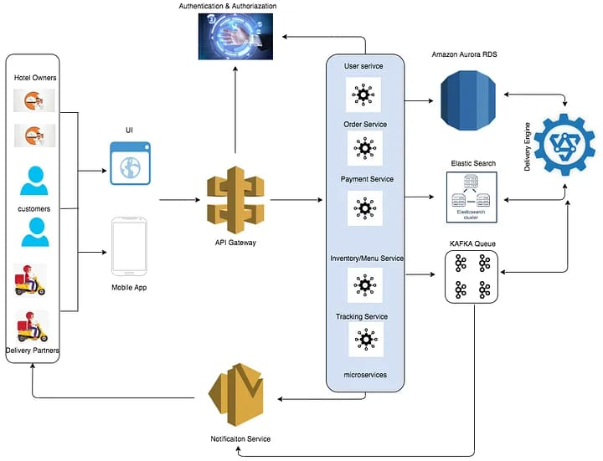

**Components of the system:**

.

1. **Front-end web or mobile application**: This is the interface customers use to generate menus,browse menus,place orders and track delivery status.
2. **Backend servers o services:** This component handles requests from the front-end,communicates with the database and coordinates with delivery partner.
3. **Database:** This stores information about menus,orders,customers,and delivery partners.
4. **API Gateway:**This is responsible for request routing,composition,and protocol translation,among other things,between an application and a set of microservices.
5. **Messaging Queue:** An asynchronous communications between systems that allows multiple systems to send and receive messages reliably and efficiency without needing to be constantly connected.
6. **Notification Service:**To send notifications to users,typically through email or push notifications.
7. **Tracking Engine:**This will constantly watch for changes in the DB,update the elastic search index ,and notify the messaging queue.

**CHAPTER 4**

**MODELING AND RESULT**

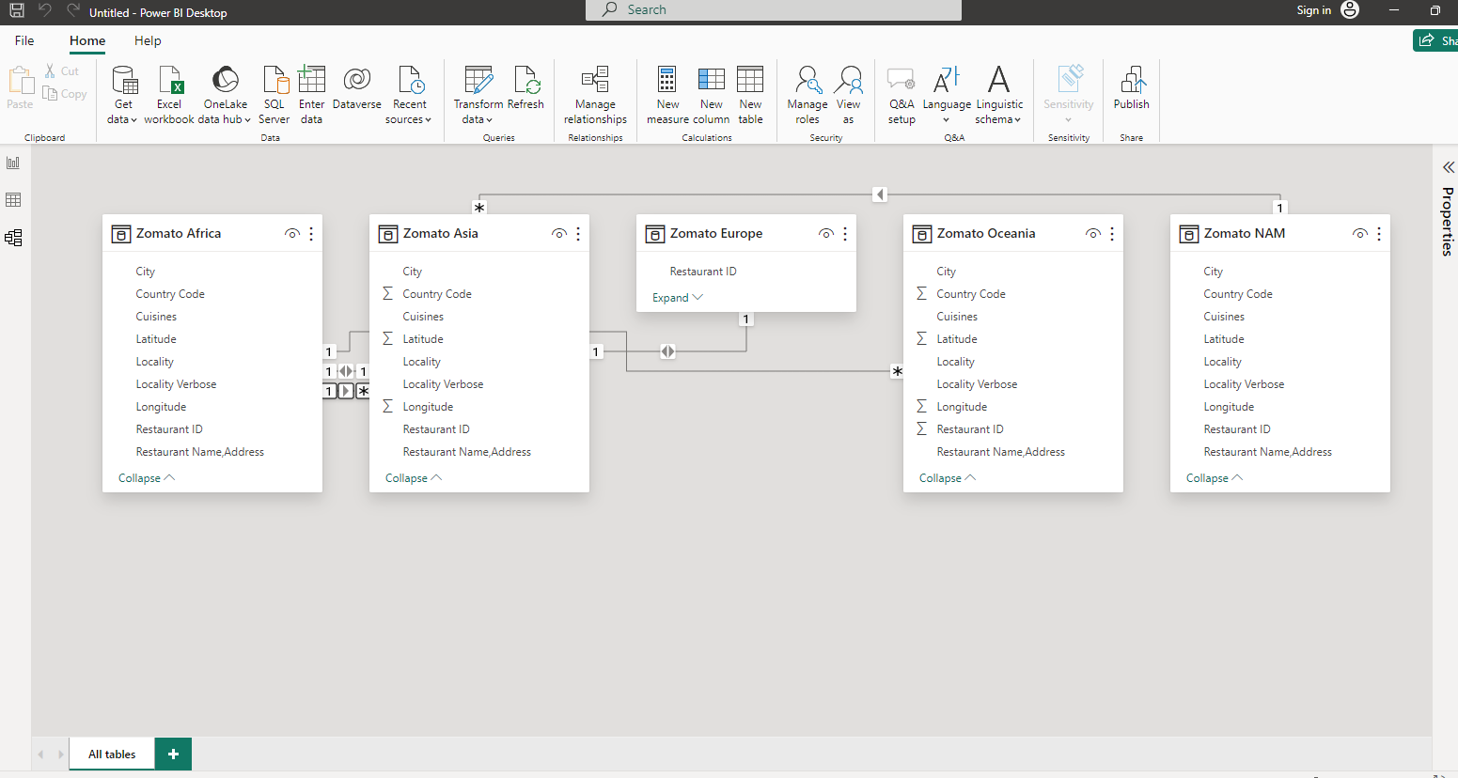

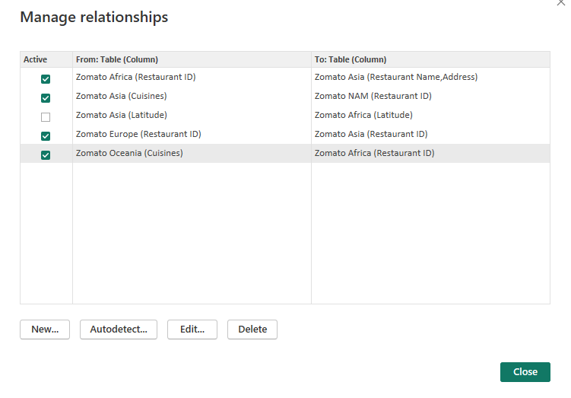

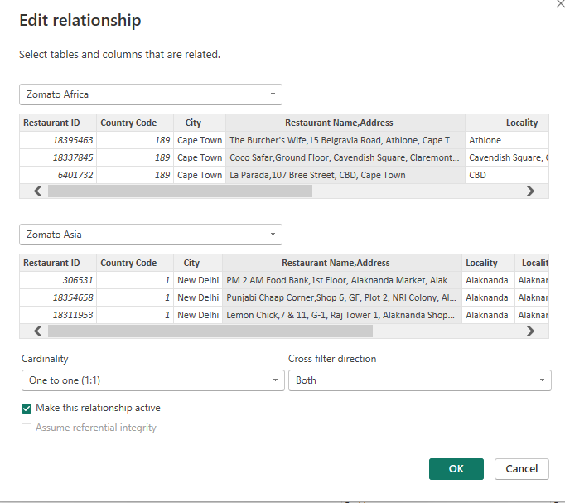

**Dashboard**

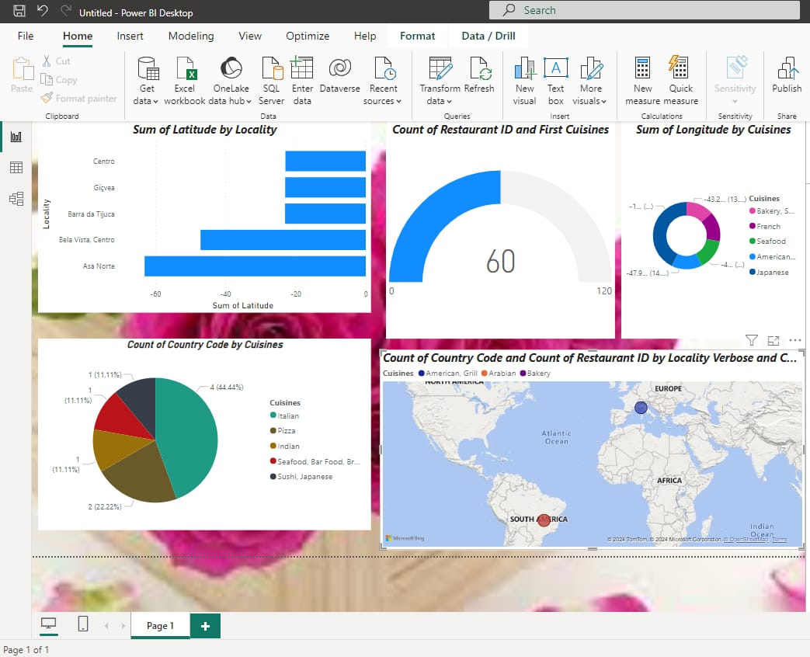

**CONCLUSION**

With the rise of the Internet and simple online access or a smartphone,food delivery services have become dramatically popular.Moreover,placing food orders online greatly saves time for consumers,while targeting new customers through food delivery solutions is becoming simpler for businesses.Furthermore,food delivery apps enable restaurant companies to fulfil the expectations and needs of rapidly growing customers and better serve them by offering a personalized experience.With that in mind ,restaurant companies should opt for the creation and deployment of a food delivery app.

**FUTURE SCOPE**

The Scope of food delivery app development is expected to grow significantly in the decade as more people rely on online food ordering .Increased smartphone usage and convenience will drive the demand for food delivery apps.

The Global Online Food Delivery market is anticipated to rise at a considerable rate during the forecast period ,2024 and 2031.In 2023,the market is growing at a steady rate and with the rising adoption of strategies by key players,the market is expected to rise over the projected horizon,15 feb.,2024.

**REFERENCES**

<https://dialnet.unirioja.es/descarga/articulo/8994373.pdf>

**LINK**